Title (type the title of your paper here, use Arial 14, boldface)

Type the authors’ name here (Leave two spaces between the authors’ name and the Title). Use Times New Roman 11, boldface.
Type authors' affiliation here. Use Times New Roman 11, italic.

Abstract (Times New Roman 11, boldface)
Type the abstract here. Use Times New Roman 10. Text should be fully justified.

Keywords (Times New Roman 11, boldface)
Type here the keywords for the paper. Use Times New Roman 10. Text should be fully justified.

TYPESET GUIDELINES

Text Formatting

Normal text should be typeset in 10 pt size and its Style and Font should be Normal and Times New Roman, respectively.
Text should be fully justified without indentations. Leave an empty space between paragraphs.
Footnotes, endnotes, figure and table captions and references should be typeset in 9 pt size.
Underlining text or mathematical symbols should be avoided. Use italics for (as presented in these guidance notes) emphasising parts of the text.
The typing area should normally contain 40-50 lines of plain text. Interline space should be single along all pages and the whole text. Spreading of lines due to occurrence of indices, fractions, special symbols, etc, should be avoided.
The authors should set the sheet in an area of 170 x 240mm. The Page Setup should be as follows:

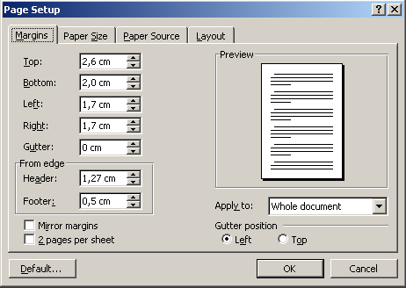

Figure 1. Typeset guidelines

Mathematical formula (fractions, indices, etc) should be typed properly according to standard typographical rules.

If necessary, use bullets in the format shown below.
- List element1
- List element2.

First, second and third level headings

First level heading should be in Times New Roman 11, bold. Leave and empty space between the heading title and the preceding and following text. There should be two empty spaces between the very first heading and the Keywords.
Second level headings should be left justified and typeset in Times New Roman 10, bold. Leave an empty space between second level headings and the text before them. Do not leave any spaces between the second level heading and the following text.
Third level headings should be left justified and typeset in Times New Roman 10, italics. Leave an empty space between third level headings and the text before them. Do not leave any spaces between the third level heading and the following text.

Figures

Leave an empty space between the figure and the text above the figure. Note that the caption goes under the figure and it should be typeset in New Roman 9. Leave an empty space between the caption and the figure and also between the caption and the text that follows. The figure and its caption should be centred. Figures should be submitted in a form suitable for reproduction (see below for an example).

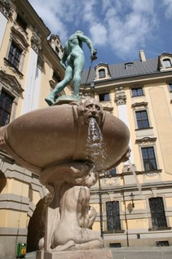

Figure 2. A view of the University of Wrocław

Tables

Tables should be submitted in a form suitable for reproduction (see below for an example) . Use Times New Roman 9 and avoid filling table cells with colours. Note that the caption goes above the table and it is also typeset in Times New Roman 9. Leave an empty line between (a) the caption and the text above, (b) the caption and the table, (c) and the table and the following text. The table and its caption should be centred.

Table 3. Values of the sound speed in aluminum, brass and copper rods, measured by using methods 1, 2 and 3, and accepted values, as reported in the literature [Handbook of Chemistry and Physics, 1974]

Rod material | Sound speed (m/s)  Method 1 | Sound speed  (m/s)  Method 2 | Sound speed  (m/s)  Method 3 | Sound speed (m/s)  Accepted values
Aluminum | (480 ± 12) x 10 | 4980 ± 80 | 4950 ± 60 | 5000
Brass | (360 ± 15) x 10 | 3440 ± 50 | 3400 ± 50 | 3480
Copper | (360 ± 10) x 10 | 3610 ± 50 | 3500 ± 50 | 3570

References (There should be an empty line before and after the references heading)

References should be ordered alphabetically and be presented as shown below. They should follow the format shown below:

Reference to a journal paper:
Wittmann, M. C., Steinberg, R. N. and Redish, E. F. (1999). Making sense of how students make sense of mechanical waves, The Phys.Teach. 37, 15-21.

Reference to a book:
Ryan, S., Scott, B., Freeman, H. and Patel, D. (2000). The Virtual University: the internet & resource-based learning, Kogan Page, London, UK.
Handbook of Chemistry and Physics 1974 55th ed. Chemical Rubber Company

Reference to a paper in conference proceedings:
Rodriguez, P., Nussbaum, M., Zurita, G., Rosas, R. and Largos, F. (2001). Personal digital assistants in the classroom: an experience. Proceedings of the Ed-media World conference on Educational Multimedia, Hypermedia & Telecommunications, Association for the Advancement of Computing in Education, 1567-1572.

Reference to papers in edited books:
Berger, C. F., Lu, C. R., Belzer, S. J., & Voss, B. E. (1994). Research on the uses of technology in science education. In Gabel D. (Ed.), Handbook of research on science teaching and learning (pp. 466-490). New York: Macmillan.

Affiliation and address information

At the end of the paper, on the left under the last reference (leave 2 spaces from the last reference), the full author’s address, including the author name, has to be placed. E-mail address may be attached as the last line. Use Times New Roman 9. For example,

Tomasz Greczyło
Institute of Experimental Physics
Department of Physics and Astronomy
University of Wrocław
Pl. Uniwersytecki 1
50-137 Wroclaw
Poland
e-mail: girep@ifd.uni.wroc.pl

Manuscript length

The completed paper including all figures, references, authors’ addresses should not exceed TEN (10) pages in 170 x 240 mm format.

Submission of manuscripts

Articles should be submitted for publication in electronic form, in Microsoft Word format, via the Conference Registration System:

http://girep2015.ifd.uni.wroc.pl/login/
Use login and password received during registration for the conference.

When logged in go to
Papers
and press the button
Add Paper.
Fill in all the spaces: Title, Description.
Add the file.
Do remember to describe the contribution!
When finished press Save.
Successful submission is visible in the account under Papers.

Please take care that the filename of your paper is in the form <Your Last Name>_Paper_<Number>.doc. In case you are making multiple submissions please use the <Number> to distinguish one from the other. For example: Greczylo_Paper_1.doc

The authors are recommended to retain a copy of their paper in order to minimise possible inconvenience.

